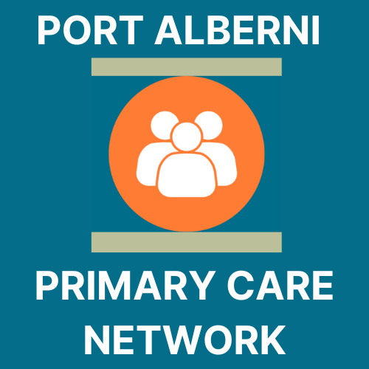
Port Alberni Primary Care Network
NIP Admin Manual

ACKNOWLEDGEMENTS
We want to acknowledge that our place of work is within the ancestral, traditional and unceded territory of the Tseshaht and Hupacasath people. We acknowledge this land out of respect for the ancestors of this place and reaffirm our relationship with one another in our work going forwards, together.
In addition, a special thanks goes to all teams that dedicated their time to this program:
- Physicians, Nurse Practitioners, RNs and MOAs
- First Nations, Métis, and Inuit Partners
- The Central Island Division of Family Practice
- Island Health Authority
- First Nations Health

Acronyms/Abbreviations
MOA | Medical Office Assistant
EMR | Electronic medical record
PCN | Primary Care Network
DoBC | Doctors of BC
CIDFP | Central Island Division of Family Practice
NIP | Nurse in Practice

This manual has been developed to assist in onboarding RNs in practice to Primary Care Networks.

First edition published in November 2023. See anything that is out of date or needs revision? Please contact PCN Administrator ___________

CLINIC INFORMATION
Address:
Office telephone:
Office fax:
Office hours:

Call-in Procedures
What if your Nurse in Practice is sick? Your nurse in practice will call the clinic if they are too ill to come to work and will also alert Island Health Staffing. A relief nurse can also be organized to cover your practice if needed.
Can Nurses in Practice work from home? Nurses in practice may be able to arrange days to work from home, so long as this is supported by your clinic and Island Health Manager.

Clinic Staff
Physician/Nurse Practitioner:
Phone: Email:
Clinic Staff/MOA:
Phone: Email:

TABLE OF CONTENTS
ACKNOWLEDGEMENTS 2
Acronyms/Abbreviations 2
CLINIC INFORMATION 3
Call-in Procedures 3
Clinic Staff 3
TABLE OF CONTENTS 4
PROGRAM INTRODUCTION 5
WHAT IS A PCN? 6
What are the benefits of a PCN? 6
Who’s who within the PCN? 6
ORIENTATION 7
Getting your office ready for your Nurse in Practice 8
What to expect. 8
MSP/Teleplan & EMR Set-up 8
NIP SCOPE CHECKLIST 10
CLINIC SHADOWING 12
PATHWAYS 13
Pathways Training 14
OTHER RESOURCES 15
QUICK REFERENCE 16
Appendix: Medaccess template services guide 17
Record of Amendments 18

PROGRAM INTRODUCTION
In March 2023, the BC Ministry of Health approved the Port Alberni Primary Care Network (PCN) service plan. The service plan contained 5 strategies to address the problems highlighted through widespread community consultation in 2021 as the main issues with accessing healthcare. The plan was written by a team made up of Central Island Division of Family Practice employees and members, Indigenous partners, and Island health employees. All groups consulted validated the plan.
This service plan includes the following 5 strategies to increase access and quality of primary care in Port Alberni:
- Community Health Centre, located in the city, creating low barrier, culturally safe access to team based care for Port Alberni’s most marginalized population of people. This health centre combines the social determinants of health approach of a community health centre with the traditional and culturally safe attributes of an Indigenous primary care centre.
- MHSU Clinic, located inside the Community Health Centre. This low-barrier MHSU clinic will act as an allied health hub, with the capacity to take referrals for attached patients from other primary care providers. This will increase access to quality MHSU services and create attachment capacity.
- Mobile Healthcare Unit, transportation barriers to accessing care for urban, rural and remote populations are widespread. There is a significant need to deliver mobile primary care services to these patients. This service strategy seeks to support our priority populations including urban Indigenous and non-Indigenous, rural and remote, as well as those who are street-entrenched.
- At 780 members, Métis represent a growing population. The MHA will support Métis clients, advocating for health provider relationships that are trauma-informed, patient and family centred and promote culturally safe experiences, as well as strengthen engagement and facilitate meaningful attachment.
This manual is intended to guide the onboarding process for the following PCN Strategy, Team Based Care:
- Team based care in family practice creates capacity to attach more patients, makes clinics more attractive to incoming physicians, reduces physician workload, creates same day access for attached patients; and aligns with PCN Attributes: Comprehensive and coordinated care; virtual care, extended hours, same day access, attachment, and culturally safe care. RNs in Practice will support this team-based care initiative.

WHAT IS A PCN?
A PCN is a primary care network that
- consists of physicians and other providers who collaborate and expand team-based supports for the GP’s and patients.
- Made up of FPs, NPs, RNs, allied health care providers, FN communities, health authority services and community health services.
- Clinical network of providers in a geographical area where patients receive expanded, comprehensive care and improved access to primary care.
- Everyone collaborates as a team to provide all primary care services for the community members

What are the benefits of a PCN?
A PCN benefits the physicians, patients and the system. The PCN
- reorganizes how the services collaborate by strengthening teamwork and communication links
- brings services together around the patient
- creates capacity in a community to increase access.

Who’s who within the PCN?
Name | Position | Email/Phone
Dr. | PCN Physician Lead
PCN Manager,
Division of Family Practice
PCN Administrative Assistant,
Division of Family Practice
PCN Change Management,
Division of Family Practice
Manager, Primary Care,
Health Authority
Executive Director,
Division of Family Practice
Clinical Operations Director,
Health Authority

ORIENTATION
Orientation for the PCN Nurse accounts for RN Experience, scope, and identifies clinic needs. Island Health has developed a two-week orientation for the PCN Nurse. (for more in formation, please consult Appendix E)

Clinics will prepare the following training for the PCN Nurse to be completed within the first 1-2 weeks in the clinic:
Clinic Active Responsibility Timeline
Send in | Clinic | 1 hour
Set up EMR Log-in credientials | Clinic | 1 hour
Train PCN nurse to use EMR | Clinic and EMR Super user | Ongoing
Encounter code reporting (trianing) | Clinic with support from CIDFP | 2 hours
Set up job shadow shifts with Physician lead, MOA, office manager, etc | Clinic

Getting your office ready for your Nurse in Practice
Now that you have selected your nurse, let’s get your office set up for them to arrive.

What to expect.
The Nurse in Practice training starts with 2 weeks of Island Health training, and then in weeks 3 & 4, your nurse will shadow in-clinic. The Port Alberni Primary Care Network also offers a workshop to help set up Encounter Templates and do a meet and greet with your new nurse.

The Port Alberni PCN Tracks patient attachment through capacity building after a new nurse in practice has started at your clinic. The family practitioner no-fee new patient attachment code that the Ministry of Health uses to track this capacity is 97671. Our Administrator will get in touch with you monthly to pull the number of patients attached using this code from your EMR.

MSP/Teleplan & EMR Set-up
STEP 1: Apply for MSP Billing Number: in this binder you will find the form Application for Billing Number (NP/RN/LPN) (HLTH2997) Fill this in and submit. If you wish to fill out online and print access the link here. https://www.health.gov.bc.ca/exforms/practitioner.html#2997 Please Note: You must have this number before proceeding to step # 2. After 2 weeks call the Practitioner Assistance line 1-866-456-6950.to get your billing number and then proceed to step 2.
STEP 2: Fill in the encounter record submission authorization for non-physician provider form (HLTH 2871). If you have more than one physician in the clinic that the nurse works with, you will need to fill in a form for each. This form is to be filled in once you have the MSP billing number from step 1. It connects the MSP billing number to an existing payee number. https://www.health.gov.bc.ca/exforms/practitioner.html#2871
**If you need assistance with set up call the Practitioner Assistance line 1-866-456-6950 or contact your PCN Administrator 250-937-9402
STEP 3: Set up your nurse in your EMR. Once you have your billing number you can add these to your nurse profile on the EMR. If you are unsure how to do this, you can contact the PCN Administrator or contact your EMR provider to help you with this process. They will also be able to help you add all your billing numbers in and activate once MSP have approved the forms you submitted. Make sure all their details are entered and create their login. You can also set up time allotment for appointments, and appointment types.

STEP 4: Set up Encounter Templates: Use the (what can my PCN nurse Do?) pages below to help decide what encounter templates you will need to add to accommodate what your nurse will be doing in your clinic. Please see attached: How to create encounter templates and macros. When setting up your templates make sure for your nurse in practice you uncheck the Rural Retention box

STEP 5: ** Set up PHARMANET access. The first part of this will need to be set up by your nurse but you can support the process. Things you’ll need: BC Services Card App, PRIME enrolment, once approved the nurse will send you the approval notification, then you set them up on PharmaNet.
Health professionals can only access PharmaNet with approval from the Ministry of Health. They enrol in PRIME to request approval. PRIME is an online application.
Independent PharmaNet users such as physicians, nurses, and pharmacists, and those who support, such as MOAs and pharmacy assistants, must enrol in PRIME. Follow the link below to set up PRIME and PharmaNet
https://www2.gov.bc.ca/gov/content/health/practitioner-professional-resources/pharmacare/pharmanet-bc-s-drug-information-network/prime

NIP SCOPE CHECKLIST
Your physician or nurse practitioner can go through this list with your PCN Nurse to ascertain their top 10 priorities in utilizing a nurse in practice to enhance their team-based care.
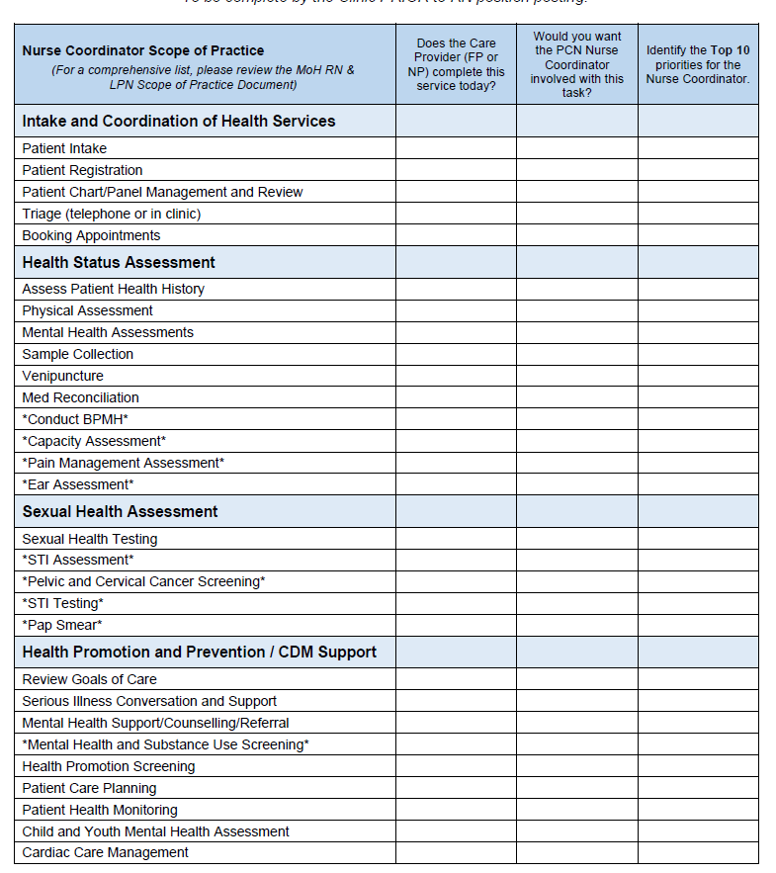
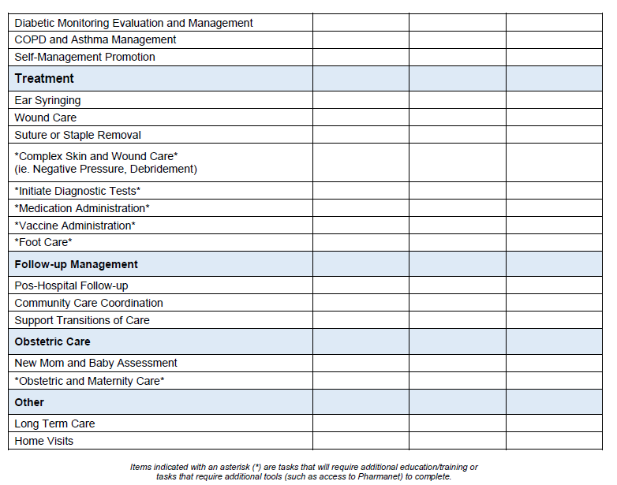

CLINIC SHADOWING
- Week three and four is the time for your nurse to settle in your practice. You should have already set up EMR Log in Credentials, and your registration with MSP should be complete.
- Make sure before week 3 if you haven’t heard already to check with MSP that your Nurse has been approved and all details are correct in your EMR. (otherwise, you will get rejections)
- Set up PharmaNet access.
- Your NIP has all the Island Health Video and EMR training links in their PCN NIP Training Manual. Your NIP should work both sides of the EMR (GP/NP and Admin) to familiarize themselves. Give direction to basic admin tasks, ie, is your MOA doing this or are you sharing?
Week 1: Island Health & CIDFP Virtual Classroom Orientation
Week 2: Mentorship and Coaching with Island Health
Week 3: Clinic Shadowing
Day1 | AM: Review EMR  PM: Buddy with Site Nurse or office mgr
Day 2 | AM: Shadow MOA’s Reception  PM: Buddy with site nurse or PCN nurse | Goal of the shadow shift is to learn the roles and responsibilities of each team member
Day 3 | AM: Shadow Physician  PM: Shadow Physician
Day 4 | AM: Buddy with site nurse or PCN nurse  PM: Shadow Physician
Day 5 | AM: Shadow Office Manager  PM: Review competencies, check in with RN team leads | Review EMR and encounter code billing
Week 4: Clinic Shadowing, Pathways
Day 1 | AM: Shadow Physician  PM: Shadow Physician
Day 2 | All day E-learning modules; support from RN team leads
Day 3 | AM: Buddy with site nurse or PCN nurse  PM: Shadow Physician
Day 4 | AM: Buddy with site nurse or PCN nurse  PM: Practice in EMR
Day 5 | AM: Shadow Physician  PM: e-learning modules | Review RN/LPN scope of practice document

PATHWAYS
Pathways is a provincial database that provides up-to-date information about specialist wait times, referral processes, and contact methods. Ask your physician/NP for access through their license. For new licenses, please contact Amanda Salvage, PA PCN Administrative Assistant to set up an access key.
Email:
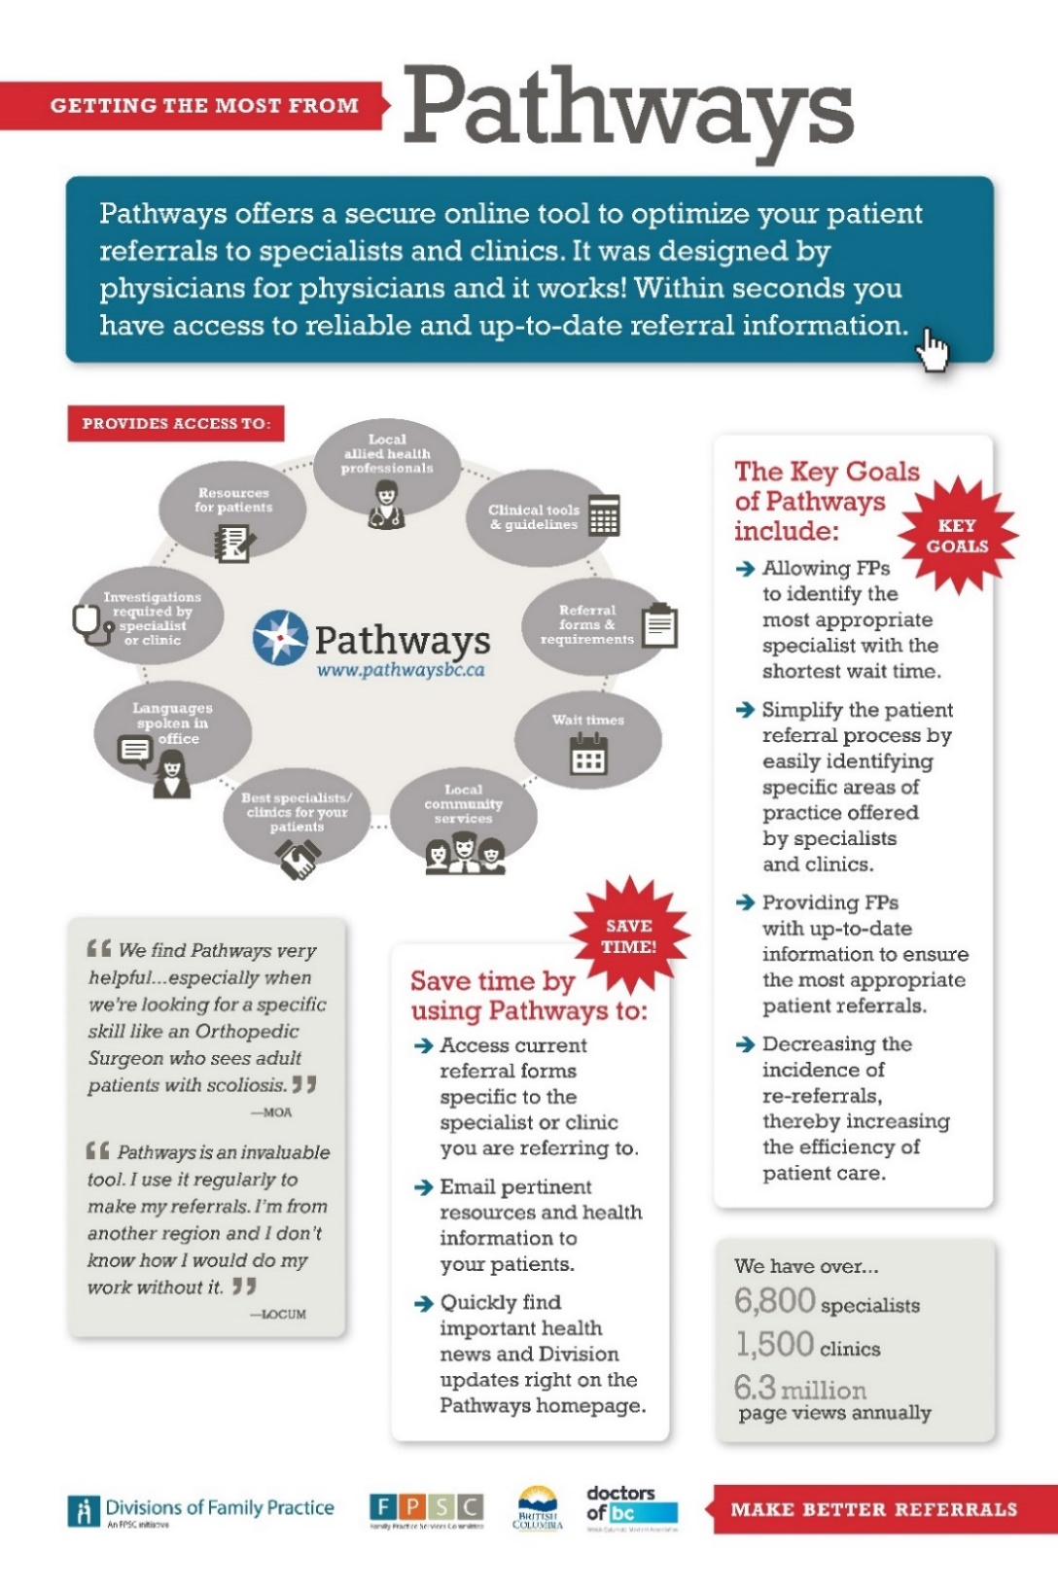

Pathways Training
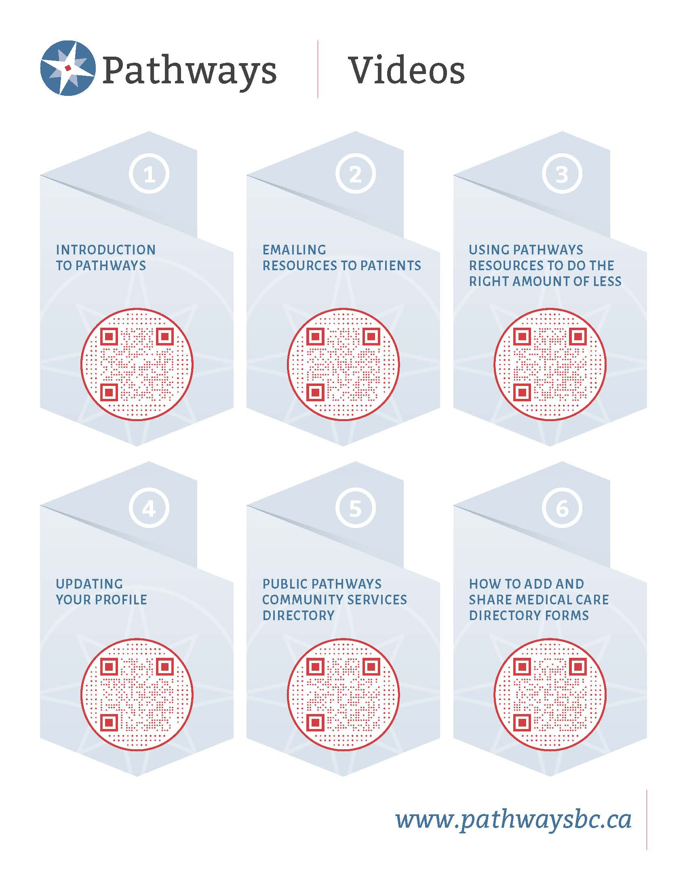

OTHER RESOURCES
Health Gateway | https://www.healthgateway.gov.bc.ca/
BCCNM | https://www.bccnm.ca/RN/ScopePractice/Pages/Default.aspx
RN Scope of Practice | https://www.bccnm.ca/Documents/standards_practice/rn/RN_ScopeofPractice.pdf
Lippincott | https://www.nursingcenter.com/login
Pathways Public Directory | https://pathwaysmedicalcare.ca/
PharmaNet: | https://www2.gov.bc.ca/gov/content/health/practitioner-professional-resources/pharmacare/pharmanet-bc-s-drug-information-network/prime
Health Connect Registry (patient registry for the province) | https://www.healthlinkbc.ca/health-connect-registry
Central Island Division of Family Practice website | https://divisionsbc.ca/central-island
BC Family Doctors Website (billing resources etc.) | https://bcfamilydocs.ca/
PRIME |  | 1-844-397-7463 or PRIMESupport@gov.bc.ca
MedAccess Help Desk: |  | 1-888-781-5553  MedAccess MOA Champion (PCN only): Amanda Salvage, asalvage@cidivison.ca

QUICK REFERENCE

Hospital
BC Ambulance
911
RCMP
911
Medaccess EMR Help Desk
1-888-781-5553
Port Alberni Primary Care Network (PA PCN)
PCN Manager:
Change Management:
Administrator:
Island Health Primary Care Manager
Practice Improvement Coach, Doctors of BC

Appendix: Medaccess template services guide

Record of Amendments
Date | Amendment page number/description | Entered By

