Project Plan

- Summary
Project Title |  | Last Revision Date |  | Projected Completion
Purpose | A statement of the issue to be addressed by the project, why action should be taken. It may include “the problem” or “the gap”. Descriptive; a couple of sentences; usually written in the present tense. E.g. “Patients in XXX are experiencing long wait times for YYYY”.
Improvement Goal | A statement of intention describing the action to be taken to address the issue stated in the “Purpose” above. It should include a general sense of how this will be accomplished, what results are expected, some indication of a metric, and a general time frame. E.g. “To improve patient experience and peer relations among professionals by working with health professionals for the next 12 months to streamline communications protocols.”
Outcomes & Indicators | Outcomes are the specific results or changes that will be effected on the intended recipients by implementing the plan.  Indicators are specific, measurable/observable pieces of evidence that the outcome has been achieved. E.g. “Outcome: Patients will receive more timely service. Indicators: Patients report reduced acceptable wait times; professionals report manageable wait times; service records indicate 30% reduction in average wait time.”

- Context
Background
Accomplishments to Date
Future Possible Improvement Goals

- Workplan
Change Concept | Starts with the underlying “cause-effect” relationship that connects the intended outcomes to the strategies and tactics employed to achieve them, then describes how it is used in the project.
Risks | Risk Probability Impact Mitigation Strategy
Activities | Activity Milestone Description Target Completion Date

- Resources
Project Governance & Reporting
Key Partners & HR Resources
Budget Summary | $’s %  Sessionals  Physician Engagement Costs  Project Mgt  Project Expenses  Overhead  TOTAL 100%

- Communications
Objectives
Key Messages
Audience
Activities | Communication Milestone Description Target Completion Date

- Evaluation
Person(s) Responsible
Evaluation Measures
Informants
Activities | Evaluation Milestone Description Target Completion Date

- Appendices & Attachments
- Project Gantt Chart
- Detailed Project Budget
- Evaluation Question Matrix

BEST PRACTICE GUIDE to the KB Division Project Plan Version 10, Oct 2, 2013
Using a Project Plan:
This Project Plan defines the scope, objectives, and overall approach for work to be completed. It is the single point of reference on the project for key Stakeholders, including but not limited to the Funding Partners, Shared Care Steering Committee, Project Physician Lead & Advisory Committee Members, Division Executive Director, and Project Manager.
In building a Project Plan, we attempt to strike the right balance between sufficient information to give context, and not wasting resources writing about the Project, instead of doing it. Language should be concise. Superfluous descriptors limited. Point form and bullet lists embraced. Respect the Audience’s existing knowledge. Limit detail where key members of the audience (Physician Lead, Advisory Committee Members, etc.) have pre-existing knowledge. Excluding appendices, the Project Plan should not exceed 5 pages. Section 1, Summary, is the most critical part of the document, and should not exceed one page.
A Project Plan is a living document that must be revised to reflect changes in the scope or nature of the assessment process. To be useful, it must be revisited and updated by regularly by Project Advisory Committees and Project Managers.
Context:
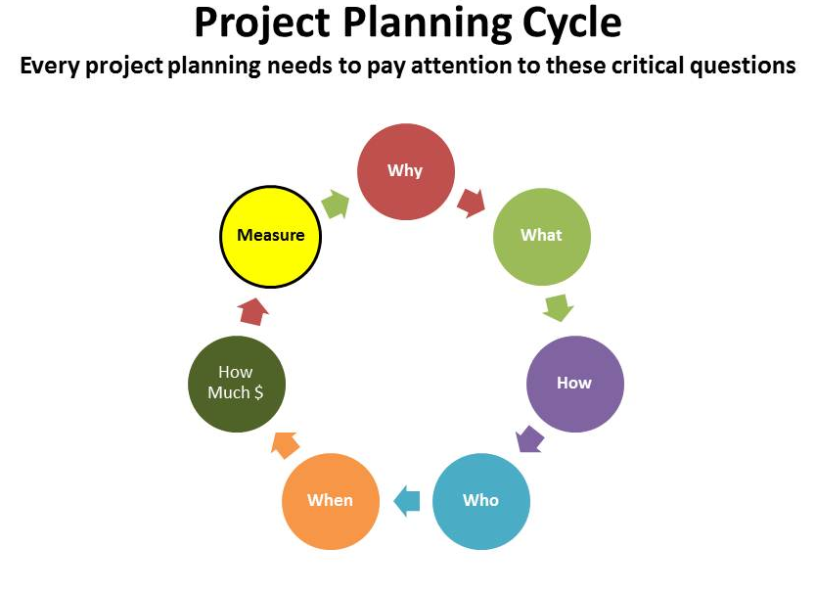 | 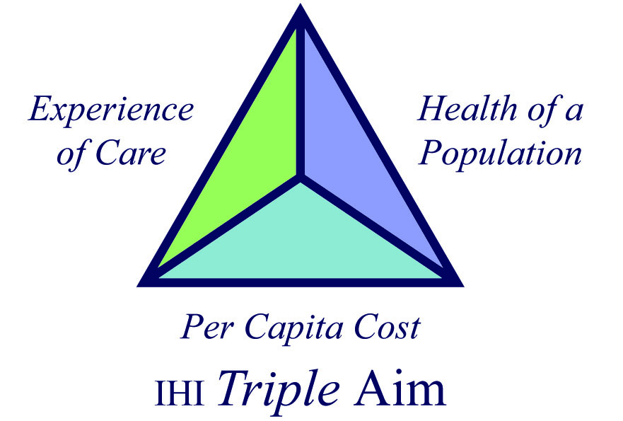 | KB Division Key Success Indicators:  1. Increased voice and influence of all stakeholders.  2. Improved quality of care.  3. Timely access to appropriate care.  4. Happier, healthier providers.  5. Increased equity in health outcomes.  6. Better use of Health Care resources

The Kootenay Boundary Division of Family Practice is committed to systematically and continually evaluating the quality and outcomes of its projects and programs, and making the necessary changes to improve them, utilizing a rigorous and iterative Project Planning Cycle.
The Division aims to increase primary health care capacity, and improve patient and population health outcomes, by developing and implementing high quality programs and services that will positively impact family physicians and their patients. All Division projects are in alignment with IHI’s Triple Aim model of Health Care Reform.
As part of its Strategic Planning, the KB Division Board has developed a series of Key Success Indicators for its work. All Division projects produce Outputs and Outcomes that are in alignment with these Indicators, and are evaluated accordingly.
Section by Section Recommendations:
- Summary
Project Title | Determine a title that will clearly identify the project broadly throughout its life-span. | Last Revision Date |  | Projected Completion | projected Improvement Goals completion (evaluation may take longer)
Purpose | Two or three concise sentences about the problem this project sets out to rectify, with emphasis on the impact on patients and providers. What is the baseline for the problem you are trying to solve. Example:  Patients living with Chronic Pain in the Kootenay Boundary do not receive best practice standard of care, resulting in a wide range of negative life outcomes. In surveys of GP concerns, Chronic Pain is consistently a “top 3” issue. GP’s are frustrated with their lack of capacity to improve health outcomes, and find multidisciplinary supportive care, for these patients.
Improvement Goals | Improvement Goals are the products, services, business or management practices that the project will “do” to solve the problem. These Goals are usually expressed as a verb that leads to a noun. Where possible, answer “how much” and “by when”. Examples:  - Host a chronic pain CME event focused on physio and exercise  - Draft a regional chronic pain management strategy  - Establish a chronic pain clinic in partnership with WCB
Outcomes & Indicators | Outcomes are the benefits or other long-term changes that are sought from undertaking the project. They are the change we wish to see resulting from the project’s Outputs. Target outcomes are typically expressed in the past tense and usually start with a word ending in ‘ed’, such as improved, increased, enhanced or reduced. The Triple Aim framework should be considered when developing Outcome statements.  Indicators are specific statements that we can evaluate, providing an evidence-based connection between achieving an Outcome and knowing the Problem Statement has been addressed. Whenever possible, it is preferable to make the Indicators numeric, even if measuring subjective change (e.g. X% of physicians feel Y or Z). They will be integrated into the Outcome assessment aspects of the Project Evaluation Plan. Examples:  - Improved ability for patients living with chronic pain to engage in normal daily activities.  - 50% of Doctors report increased patient mobility after the CME Event  - WCB reports a 35% decrease in “back to work” time for patients referred to the new Pain Clinic  - Increased satisfaction for GPs caring for chronic pain patients  - 90% of GPs report an increase in confidence referring and caring for patients living with chronic pain  - Decreased costs to the system via decreased visits to GPs by patients living with chronic pain  - GPs report a 75% decrease in visits to their offices by patients that have completed the Pain Clinic’s 6 month program.

- Context
Background | A paragraph (or two or three, as required) providing a more detailed history of the issue, the parties involved in addressing it. What stakeholder’s have been addressed to date. To the extent that the “Problem Statement” in section 1 needs elaboration, this is the place. Here too could reside the evidence basis for this project. 3rd party data that supports that completing these Outputs will result in Outcome achievement.
Accomplishments to Date | Quick bullet list – Outputs achieved to date & evidence of Outcome achievement. Likely only required for drawn out projects with multiple Outputs, in the “mid-term” of their life-cycle.
Future Possible Improvement Goals | Quick bullet list - The “parking lot”. Issue that have come up during consultation that could be worked on in the future, and we don’t want to lose, but are not considered priorities at present.

- Workplan
Change Concept | A few paragraphs providing a narrative overview of the planned approach to completing this project. Describing the work that will be undertaken, in logical phases. In this section, the reader will be educated in “best practice” of project management. Liberal use of terms and models such as F.O.C.U.S., PDSA, Evidence Based, Socializing Change, Rapid Prototyping, etc., is appropriate. This is the place to help stakeholders understand that what appears to be a basic change process, is in fact complex and multi-faceted. In particular, emphasizing how initial PDSA cycles will minimize complexity and risk, is advisable.  The Shared Care “formula” for project engagement may by be relevant here:  - Meeting 1: Meet all the stakeholders, relationship building, background on activity, lay of the land. Evaluation metrics, etc.  - Meeting 2-3: Identify issues, gaps, challenge. Understand and appreciate each stakeholders “perspective”. Pealing the onion.  - Meeting 3-5: Collaboratively develop and test solutions. Oversee the implementation of solutions.  - Meeting 6-7: Ensuring solution sticks, and supporting the spread. Evaluation wrap up.  Relevant IHI Project Stages could/should also be identified:  - Innovation  - Testing  - Spread/Scale-up  Over time, as the Division becomes more sophisticated and experienced in Project Delivery, this section may shrink, and the Activities/Milestones section below suffice to describe planned project activities.  END WITH DISCLAIMER – IT WON’T GO THIS WAY… BUT IT WILL BE SIMILARLY COMPLEX
Risks | (This content could be built into the section above, or looked at separately)  Risk Probability Impact Mitigation Strategy / Tactic  3-5 critical issues to consider, that could derail the project. Examples: Physician Engagement, Health Authority restructuring, etc. Is this likely? Subjective – high, med, low Is this consequential? Subjective – high, med, low List actions/strategies that will be undertaken to minimize the likelihood of derailment.
Activities | Activity Milestone Description Target Completion Date  Summarizing the Strategic Approach section above, 4 to 7 key deliverables for the project are identified as “Milestones”. This section provides a quick overview of the entire project. Imagine you could use this as an elevator pitch answering the question “What are you going to do?”. Brief descriptor, if required. Sure, things change, but if we don’t set goals…

- Resources
Project Governance & Reporting | What structures with the KB Division is the project Governed by, and reporting too. Examples:  Division Board, Shared Care Steering Committee, Project Advisory Committee, Provincial Steering Committee, Executive Director  How frequent is the reporting to these entities? What report template or tool is required (if any)?
Key Partners & HR Resources | What are the names of all the parties involved in the project, both Governance and Operations. Exclude the Division Board as an entity. Include Board Members directly involved in the project.
Budget Summary | High level summary of the Project Budget. Details provided in attached documentation, if required.

- Communications
Objectives | Quick numbered list of “the point” of rolling-out a small handful of communications deliverables for this project. Examples:  - Motivate Advisory Committee members via a focus on success.  - Expedite buy-in by non-engaged Specialists & GP’s during roll-out of the full project.  - Maintain Health Authority commitment to addressing the issue.
Key Messages | What are the critical stories that must be told during evolution of the project to achieve the Communications Objectives above. What will motivate our target audience to support and engage in the project? Examples:  - Patient satisfaction increased by 75%  - 9 o f10 GPs report substantial decreased GP frustration with referrals  - Key opinion influencers have signed on to initial pilot implementation of project  - Savings of $X estimated, or validated
Audience | List of the Key Stakeholders that need to hear the Key Messages to achieve the Communications Objectives.
Activities | Communication Milestone Description Target Completion Date  4 to 7 key deliverables for Communications effort. These “tactical outputs” paint a picture of what the Audience will experience over the life of the project. Examples: Report Card 1,2&3; Presentation to LMAC; Booth at Health Fair; Press Release to local papers; GP Story in Division Monthly Email & Website Brief descriptor, if required. Sure, things change, but if we don’t set goals…

- Evaluation
Person(s) Responsible | Names of members of the project team, and or external consultants, leading the Project’s evaluation efforts.
Evaluation Measures | What do we wish to determine in evaluation of this project. These typically would be similar for most Division Projects.  Shared Care Framework:  - To what extent is the project achieving its planned results?  - To what extent has the project implemented as planned?  - To what extent has the project been able to identify and successfully engage stakeholders?  - What lessons does the project provide that could be used to improve patient care and efficiencies in other populations or locations?  - How effective is the project in sharing what is learned?  IHI Framework:  - EXPERIENCE - What was the participants’ experience? Did they have an excellent experience working on the improvement project  - LEARNING- What did participants learn? Did they learn improvement methods and begin testing or spreading?  - PROCESS/BEHAVIOUR - Did participants modify their behavior? Did they work differently and see change in their process measures?  - OUTCOMES - Did the organization improve its performance (via outcome measures)?
Informants | List of key stakeholders that can make a contribution to answering the Key Questions.
Activities | Evaluation Milestone Description Target Completion Date  5 to 10 deliverables that will drive a successful evaluation. Examples: Patient Survey 1 & 2; GP & Specialist Interviews 1 & 2; Prototype Surveys; Advisory Committee quick-evaluation at conclusion of each meeting; As required. …

- Appendices & Attachments
- Project Gantt Chart
  - Amalgamated Milestones and Target Completion Dates for Activities, Communications, Evaluation, Reporting, etc., with more details about work the project participants are undertaking
  - See Andrew’s Excel example utilized for the 2013 Spring Round Table
- Detailed Project Budget
  - Division Master Budget
  - Excel Template – in process
- Evaluation Question Matrix
  - See Stephen Reichart examples for Shared Care 2013 evaluation.

