Cowichan

Primary Care Network Steering Committee

Terms of Reference (TOR)

Cowichan partners are committed to an inclusive collaborative approach to implementing Primary Care Networks (PCNs) and interdisciplinary team-based care. The following chart depicts the organizational structure for the Cowichan PCN.

Organizational Chart

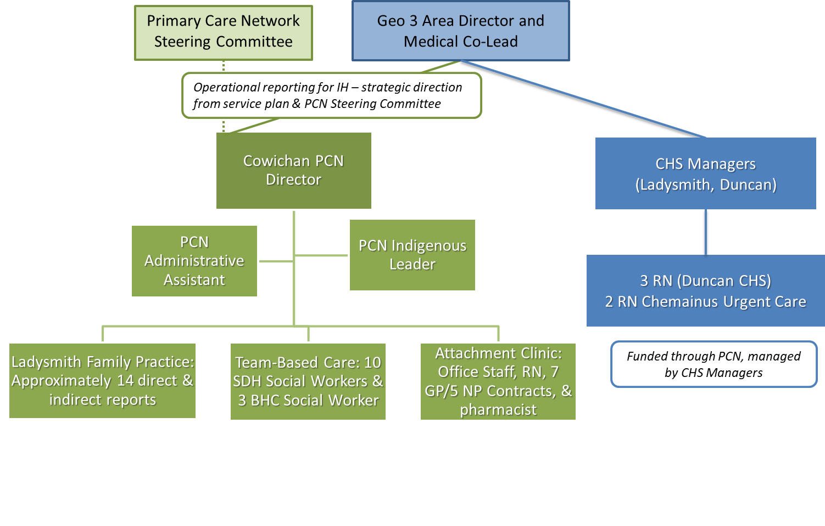

Background
In connection with the Ministry of Health initiative to transform primary care in the province of British Columbia through the creation of Primary Care Networks (PCN), the Cowichan Primary Care Network (Cowichan PCN) has been formed and serves a population of approximately 91,000. The area served by the Cowichan PCN includes the following areas:

Community health service areas as follows:
- South Cowichan
- Central Cowichan
- Cowichan Valley West
- Ladysmith
- Ladysmith Rural
- Chemainus
- Thetis Island

First Nations traditional territories as follows:
- Cowichan Tribes
- Penelakut Tribe
- Halalt
- Lyackson
- Stz’uminus
- Malahat
- Ts'uubaa-asatx
- Ditidaht

In 2019, The Cowichan PCN team developed and submitted a Service Plan for the Cowichan PCN to the Ministry of Health (“PCN Service Plan”), and the PCN Service Plan was approved by the Ministry of Health in 2020.

Purpose
The Cowichan PCN Steering Committee will provide the strategic direction for the implementation and ongoing function of the Cowichan PCN within the spirit and intention of the Cowichan PCN Service Plan. The PCN Director is responsible for the day-to-day operations of the PCN.

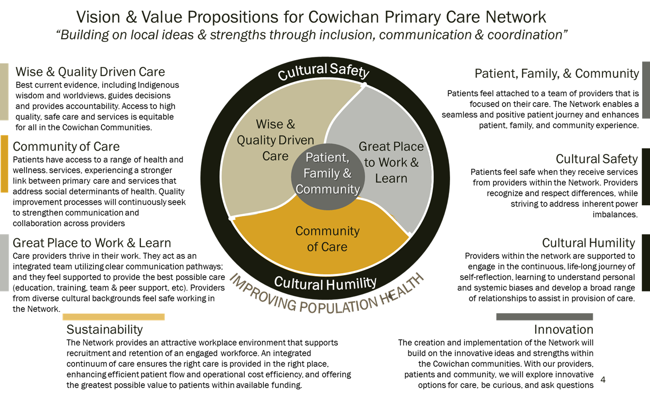
Guiding Principles

Responsibilities of the Steering Committee
- Ensure the Cowichan PCN is inclusive of all residents of the Cowichan communities.
- Uphold the Cowichan PCN Vision and Value Propositions (see previous section).
- Ensure that the PCN adheres to the principles for Primary Care Networks set out by the Ministry and GPSC.
- Support the equitable distribution of resources across Cowichan patient medical homes and the full integration of PCN resources with existing patient medical homes.
- Attend PCN Steering Committee meetings.
- As required, act as a sounding board and help remove barriers and contribute to solutions for the effective management of the PCN by the PCN Director.
- Review and provide feedback on the annual overhead plan prepared by the PCN Director.
- Hire PCN Director within the parameters of Island Health human resource policies.
- Day-to-day decisions and operations of the PCN rests with the PCN Director.

Decision-Making
Approach:
- We see every interaction as an opportunity for positive collaboration.
- We ensure that everyone feels heard and that their perspective is valued.
- We use curiosity to achieve understanding.
- We believe that dialogue is the foundation of partnerships.
- We separate dialogue from decision making and we stay in dialogue until consensus is reached.

Decisions will be made by consensus. Consensus is achieved when everyone accepts and supports a decision and understands how it was reached. In meetings where significant decisions are to occur, all partners will be notified and encouraged to attend. If consensus cannot be reached, a higher level of consensus decision-making will be implemented. The group will return to dialogue about the decision with periodic check-ins to see if individuals are supportive, undecided, or not supportive. Dialogue continues until the majority are supportive.

Quorum: 30% attendance with minimum representation of 1 from each: Cowichan Division of Family Practice, Indigenous, and Island Health.

Membership
- 3 members appointed by Island Health, 3 members appointed by the Cowichan Division of Family Practice, and 3 Indigenous members as determined by survey of Indigenous organizations/First Nations communities.
- Term of membership is to be reviewed every 2 years. There will be no time limit on membership.
- Changes to membership – consensus and dialogue of committee members.
- Can invite advisory/ad hoc members who do not participate in formal decision-making but can participate in the Committee discussions.
- Key linkages (the following are examples & not limited to):
  - Cowichan Collaborative Services Committee
  - Our Cowichan Community Health Network
  - Community Action Team
  - Eldercare Project in Cowichan
  - Cowichan Leadership Table
  - Regional Primary Care Strategy Team (I.H.)
  - General Practice Services Committee
  - Ministry of Health
  - Cowichan District Medical Society
  - Cowichan Integration Care Cabinet

Meetings
Quarterly
Agenda by PCN Director and Assistant
Facilitated by PCN Director
Minutes taken by PCN Assistant and distributed within a week of meetings

Reporting
The minutes will reflect the decisions made by the PCN Steering Committee. Minutes will be distributed to meeting attendees and will be available to the Ministry of Health, and GPSC upon request.

PCN reporting to the Ministry of Health is evolving and is shaped by the requirements of the Ministry PCN leadership. The PCN Director is responsible for ensuring reports are completed and submitted within the deadlines given. All reports to the Ministry are accessible to the PCN Steering Committee upon request.

Confidentiality
All materials produced and presented to the Steering Committee are the property of the Primary Care Network and confidential to this committee within their stated purpose. All members of the Steering Committee are required to maintain the confidentiality of all materials, documents and discussions. Any communications that are of a public nature will be clearly identified as such and must be approved by the B.C. Ministry of Health in accordance with stated communications policies.

Amendments
These Terms of Reference will be reviewed on an annual basis and/or at the discretion of the Steering Committee. Any proposed revisions will require approval of the Steering Committee.

