Optimizing accessible primary care service delivery with coordinated, team-based, culturally safe approaches.
Nurse Practitioner Orientation Document
Contents

Introduction 2
What is a Primary Care Network (PCN)? 2
Week One 2
Meeting Key Players 3
Completion of Forms 3
Community Integration 3
Introducing the NP Role to clinic team members 3
Introducing the NP Role to patients 4
Introducing the NP Role to the Community 4
Introducing the NP to Specialists 4
Scheduling 5
Creating your Schedule: 5
New Patient Visits 5
Prior to a new patient visit: 6
During a new patient visit: 6
After a new patient visit 6
Applying for Privileges 6
Continuing Education 7
Funding Application 7
Suggestions for Continuing Professional Development Opportunities 8
Appendix A: Names and Contacts 9
Appendix B: Checklist to discuss with MOA/Clinic Manager 10

Introduction

Welcome to your new position as a Primary Care Network Nurse Practitioner. We are excited to have you join the Central Interior Rural community. This package will, hopefully, make your transition to practice easier as it highlights many of the need-to-know topics and people.

If you have any questions or concerns about anything please feel free to contact PCN Manager, Debbie Grimes or Change Management Coach Tanya Kielpinski (see Appendix A for contact information). If you have questions specific to NP practice, Julia Walker is the Regional NP Lead for our region. Her contact information is also included in Appendix A.

What is a Primary Care Network (PCN)?

A PCN is a clinical network of local primary care service providers located in a geographical area, with patient medical homes (PMHs) as the foundation. A PCN is enabled by a partnership between divisions of family practice and health authorities. The goal for PCN is to allow everyone who wants a Primary Care Provider (GP or NP) to be attached and to be able to access team-based care that extends beyond just their Primary Care Provider.

Some Nurse Practitioners within the Central Interior Rural PCN are autonomous providers and are paid through a contract with the health authority, others are employees of the Interior Health Authority. Regardless, PCN NPs are responsible for providing primary care to a panel of patients. Over a three-year period, NPs working in urban areas of the region are expected to attach 800 patients. If working in First Nation communities, the attachment target is 600 by year 3.

Week One

For NPs employed by IH, you will be engaged in their orientation processes. For NPs on contract, you too will be engaged in orientation activities with the host clinic. However also take time during the first week(s) in your new role to set yourself up for a successful career in primary care. Spend the first week or two not seeing patients but rather setting up the systems, schedules and structures required to build a well-organized practice. This is a gift to your future self; it will help to reduce future burnout and mistakes.

Read through this entire document, it will give you an idea of the many administrative and relational tasks that you need to accomplish. Keep a list of questions and reach out to your PCN Manager or coach at anytime.

Meeting Key Players

It is important to reach out to a number of key individuals when embarking on this new PCN adventure. In relation to your NP Practice, you’ll want to connect with:
Clinical Practice Lead

As part of your clinic orientation, you will meet the following people (see Appendix B for a list of potential questions to ask):
Clinic Manager
MOA
Lead Physician
Other co-located members of the team

Once settled into the clinic you will also meet the PCN Team:
PCN Manager
PCN Change Management/Practice Support Coaches

Completion of Forms

Prior to starting practice there are a number of forms that need to be completed. These may be provided to you by your clinic manger. If not, please find the list below with hyperlinks to the forms.
Application for Teleplan Services
Excelleris Electronic Distribution Application
Pharmanet Application
Lifelabs Form
Team Charting Agreement

Community Integration

Introducing the NP Role to clinic team members

While NPs have been in BC since 2004, there are still many members of the health care team that are not familiar with the role. Take time when you start to introduce yourself to the MOAs, clinic manager, physicians, RNs, pharmacists and any other members of the health care team that you will be coming in contact with regularly. Explain who you are and answer any questions they may have about your role. Review the FAQ re NPs on p. 10 in the link below:
http://bcnpa.org/wp-content/uploads/BCNPA-Toolkit-Final-Dec-21-2017.pdf
This will give you clear concise answers as you lay the groundwork for many years of a positive, productive working relationship.

Introducing the NP Role to patients

NPs transition into practice will be smoother if patients receive some education about the NP role prior to their first visit with the NP. Discuss with your MOAs an “elevator speech” that they can say to patients the first time the MOA’s book the patient with the NP. An example is, “I am booking you in with NP Sarah Jones. Sarah has recently joined our team and will be your primary care provider. Do you have any questions about this?” Prepare your MOA’s in advance with answers to frequently asked questions (p. 10 in Toolkit). When patients arrive, it may be helpful to give them a copy of the NP information sheet (p. 11 in the Toolkit) or have it in poster form on the wall.
If the patient is being referred from the centralized CIRD waitlist, the MOA working with the Attachment Mechanism will have held a preliminary conversation with the patient regarding the role of an NP and gained consent to the referral.

Introducing the NP Role to the Community

Create a spiel to introduce yourself to the community. It can go on the clinic website or, in smaller towns, can be run in the local newspaper. Here is a template that you can adapt:

The Interior Medical Clinic is pleased to announce that NP Sarah Jones will be joining our team. NP Jones will be accepting new patients starting date.

NP Jones’ background in rural primary care, seniors care, mental health and substance use will be a wonderful asset to our existing physician team.

Sarah Jones is a Family Nurse Practitioner (NP). Family Nurse Practitioners have been providing care to British Columbians since 2004. NPs are able to provide full service primary care. NPs diagnose and treat medical conditions, prescribe medications, order lab work, order imaging and refer to specialists.

Introducing the NP to Specialists

NPs may encounter a situation where specialists will not see their patients due to a belief that they cannot bill for these visits. Education is the best approach. Feel free to use the template below to educate specialists.

To Whom It May Concern:
Interior Medical Clinic is pleased to announce that NP Sarah Jones has joined our clinical team. She is a Nurse Practitioner and will be building a panel of primary care patients. NPs MSP numbers do allow you to bill for a specialist consult fee, the process is the same as billing Physician MSP numbers for a specialist consult fee.
Thank you for your ongoing support of our clinic and our new providers.

Communication
If seeing a patient for episodic care, who is attached elsewhere, please remember to send a note to the MRP to ensure that provider is aware. This keeps all patient information centralized with the MRP and prevents confusion regarding who the MRP is.

Scheduling

Creating your Schedule:

As a PCN NP working on a PCN Contract you are expected to work 1680 hours over 44 weeks. This allows for 12 statutory holidays and approximately 6 weeks of vacation. As an employee of Interior Health, your employment details will differ based upon your FTE and orientation to your practice will provided by their NP Practice Leads.

Regardless, you will need to take time prior to starting to plan out your schedule. Remember that some weeks will be busier than others. Remember that you need time to chart, complete tasks, attend team-based care meetings and track down missing information. If you are a part of a call group or providing in patient care you will also need to factor time in for doing rounds and seeing patients.

For contracted NPs, it is recommended that you spend the first one to two weeks getting organized, completing paperwork and planning your schedule. During this time, we will also be providing you with an orientation to PCN.

Make sure that you are very familiar with your EMR and it is set up how you like it. Learn how to create recalls, record immunizations, populate a patient profile, create clean medication lists and implement workflows.

Block off admin and catch-up time. Work with your MOA to create pre-set booking blocks for a “Visit” and a “New Patient visit”. This will make sure that the correct amount of time is blocked off in your schedule. You may also want to make visit blocks for “Procedures” and “Mental Health/Counselling”.

The following recommendations are time allotments for an NP that is in a new practice. New graduate NPs may need 10-15 minutes longer than the recommendations provided. As NPs become more confident in their practice, they may reduce times to fit their individual workflow:
New Patient Visit: 45-60min
Follow up visit: 30min
Procedure (IUD insertion, excision): 60min
Mental health/counselling 30-45min

New Patient Visits

The following activities are ones you may want to consider when scheduling a new patient. These include activities that occur: before the visit, during the visit as well as after the visit.

Prior to a new patient visit:
- Obtain previous records
- Have MOAs ensure that the patient is aware that you are an NP and has received a brief education about what an NP is (see above)

During a new patient visit:
- Completion of the patient profile including:
  - Allergies
  - Past medical history
  - Family history
  - Substance use
  - Medications taken
  - Screening test (up to date and outstanding)
  - Immunizations
- Outstanding concerns that cannot be put off until another visit (if possible specific chief complaints should be booked in a subsequent appointment)
- Baseline metrics (vitals, height, weight)
- Order outstanding diagnostic tests (screening and monitoring).
- Book next appointment to deal with non urgent outstanding issues and screening (ex. Pap smear).

After a new patient visit
- If you did not review the patient’s old chart prior to the visit, review it now.
- Create tasks/reminders for upcoming tests/procedures (ex. Colonoscopy, pap smear, mammogram, possibly chest x-rays)
- Complete profile including care plan and any specifics re specialist recommendations

Applying for Privileges
Applying for privileges can be an onerous process. Please set aside time to gather the needed documents and complete the paperwork. You may need as much as 2-3, 8-hour days to complete this process the first time. If you have completed this process for another health authority it should not take as long.

The first step for applying for privileges is to send a Letter of Intent addressed to your chief of staff (see appendix A for contact information). Send this letter to the chief of staff and cc the privileging officer (see Appendx A for contact information). The letter must include the following:

- Full legal name (as it appears on your license)
- Date of birth
- Contact phone number (preferably a cell number)
- Confirmation of:
  - the email address you wish your application forwarded to: Personal or IH?
  - your specialty: Nurse Practitioner
  - category of medical staff requested:
- Start date (When would you like your privileges to be effective)
- should also outline your experience/qualifications and your plans (ie. what you would like to be able to do at your hospital)

You will then receive an email from noreply@bcmqi.ca which contains a link for you to set up a user account to access your electronic credentialing process.

As part of the authentication process, a Credentialing and Privileging ID is required to access your application in AppCentral. For security purposes you will receive your Credentialing and Privileging ID (eg. CPxxxxxx) in a separate email which you will receive after the application is sent.

In order to complete the privileging process you will need a number of documents, begin to gather these now.
Documents you will need:
- Proof of graduation from an accredited NP program
- A Certificate of Professional Conduct from BCCNM (see appendix A for example)
  - There is a cost involved. Contact Manpreet.sharma@bccnp.ca if you have difficulty finding the form to request the letter.
- Photo ID
- Picture

You will also need to have the name and contact information of references.

You will want to apply for core privileges. You may be granted associate privileges and have stipulations regarding course work and mentorship that will need to be completed prior to receiving full privileges. See continuing education below and acute care course.

Continuing Education

Funding Application

As a PCN NP you are eligible for up to $5000 of continuing education dollars per year. This can be accessed through NNPBC. The fiscal year is April 1- March 31. Education allotment as calculated based on FTE and, if you have worked less than a year, number of months worked (see tables below).

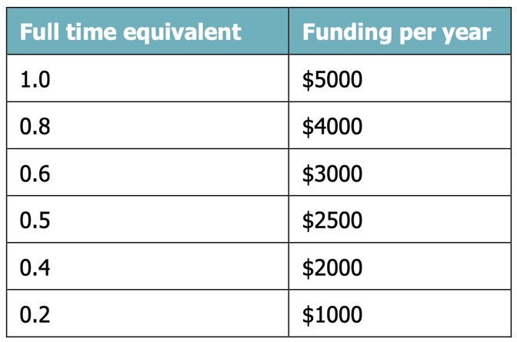
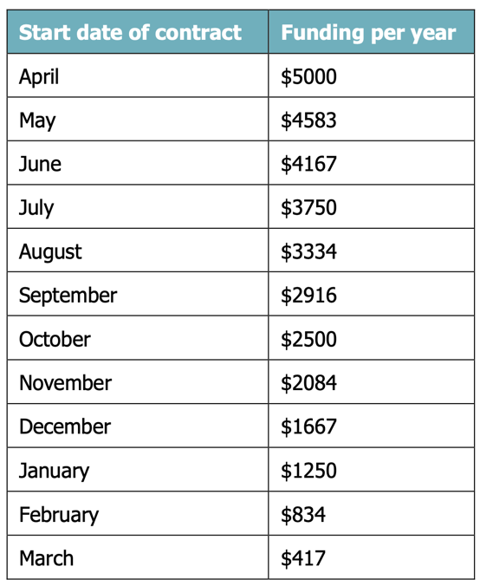

The application for funding is completed and submitted online at:
https://www.nnpbc.com/pdfs/portals/np/NNPBC-NP-CPD-Policy-Guidelines.pdf

Suggestions for Continuing Professional Development Opportunities

The table below outlines suggested opportunities for continuing professional development.

Course | Comments | Link
Certificate in Hospital & Acute Care for NPs | Helpful to take while being mentored in acute care | https://bloomberg.nursing.utoronto.ca/pd/courses/np-acute-care-certificate/
St. Paul’s CME for Primary Care Physicians |  | https://stpaulscme.org
NNPBC Annual NP Conference |  | https://www.nnpbc.com/events/
Best Science Medicine Podcast | Primary Care Focus  Created by providers in Alberta and British Columbia  Free membership and $50 membership | https://therapeuticseducation.org/bs-medicine-podcast

Appendix A: Names and Contacts

There are a number of people in the Central Interior Rural Region, both in the Divisions of Family Practice and within Interior Health, that you may need to access.

Name | Position | Organization | Contact Information
Debbie Grimes | PCN Manager | Divisions of Family Practice | dgrimes@divisionsbc.ca
Kelly Dillon | PCN Manager | Interior Health Authority | Kelly.dillon@interiorhealth.ca
 | Clinic Office Manager
Tanya Keilpinski | Change Management Coach | Divisions of Family Practice | tkeilpinski@divisionsbc.ca
Dr. Louann Janicki | Nurse Practitioner Regional Department Chair | Interior Health Authority | Louann.janicki@interiorhealth.ca
Julia Walker | Nurse Practitioner Regional Lead | NNPBC | jwalker@nnpbc.com

Appendix B: Checklist to discuss with MOA/Clinic Manager

- Username and Password for EMR
- Username and Password for meditech
- Access to pathways
- NP schedule and how to book
- What is the clinic schedule? Are there specific changes given covid that I should know about?
- Ordering a stamp (Clinic stamp with address. Personal stamp). Do not put NP on your personal stamp. It should look like this:
Sarah Jones
MSP: 11111
CPSID 2222222

- Are there regular clinic/staff meetings? When are they? Have these booked off in your schedule
- What can you delegate? What can’t you delegate?
- Who can help you set up your dashboard in your EMR?
- Set up the following workflows: INR button on task form, Send to Reception button on Task form
- Are there additional forms that the clinic needs you to complete?

