Advanced Team Canvas Instructions

Use these instructions with the Advanced Team Canvas Template

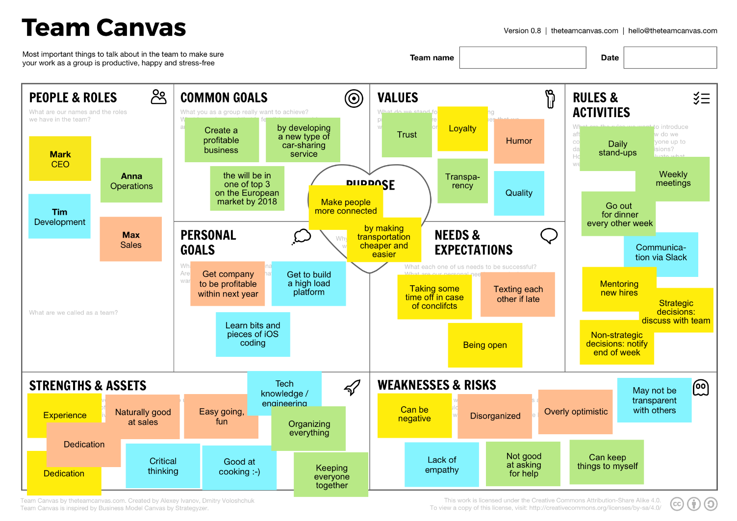

The Team Canvas:
- Fosters conversations that helps build and nurture effective working partnerships/teams
- Helps partnerships/teams to get on the same page as how they approach the work they do together
- Encourages “in the moment” opportunities to discuss “pinches or rubs” in partnerships/teams
- Creates a platform to build a Team Agreement
Process for the Activity
- Allocate anything from 1 hour 30 mins to 2 hours to complete this exercise (don’t rush though, breathe and let generative “what else if possible” conversations happen)
- Together work through and discuss the various sections in the template as listed below
- It does not have to be sequential. Start with what resonates the most for you (Hint: Purpose can be a good place to start)

- People & Roles (5 mins)
A simple introduction to clarify roles and titles. Ask everyone to fill out a sticky note in a different color and place it in the People & Roles section. You should only need five minutes for this. If you want to dive deeper, you could also use the Team charter template for this section.
Questions to ask:
- What are our names?
- What are the roles we have in the team?
- What are we called as a team?
- Common goals (10 mins)
Ask the team to agree on common goals for the team by writing their ideas on sticky notes, then discussing the most important ones. These may already be known, or you may need to work them out now.
Questions to ask:
- What you as a group really want to achieve?
- What is our key goal that is feasible, measurable and time-bounded?
Examples:
- Sell out tickets to our Gala night by 30 June.
- Launch our new service in the US by the end of the year.
- Personal goals (5 mins)
Ask your team members about their individual goals. These are individual, so ask everyone to place one or two sticky notes in this section, and discuss if you have time.
Questions to ask:
- What are our individual personal goals for this project?
- Are there personal agendas that we want to open up?
Examples:
- Become more confident using the event management software.
- Write weekly for our blog
- Purpose (10 mins)
Ask the team to go one step beyond their common goal, and ask them why they do what they do. If team members are not sure, ask them, what makes them get up in the morning? Or what they were most excited about when they first applied for this job. There are no right or wrong answers here.
Questions to ask:
- Why are we doing what we are doing in the first place?
- What is something more important, which makes us pursue our common goal?
Examples:
- Become a thought leader in this field.
- Share knowledge and help people achieve their goals by using our software
- Values (10 mins)
Ask the team what are their core values? As a team, what do they want to be known for, within the organization or in the greater community?
Questions to ask:
- What do we stand for?
- What are guiding principles?
- What are our common values that we want to be at the core of our team?
Examples:
- Environmentally friendly
- Pushing the boundaries
- Cooperative
- Ingenuity
- Strengths & Assets (15 mins)
Ask the team to share the key pieces of skills and assets available within the team. These can be everything from hard skills such as software knowledge, creative skills such as photography or interpersonal skills such as a good mediator. It’s good for people to share something about themselves, as well as important qualities they see in their teammates.
Questions to ask:
- What are the skills we have in the team that will help us to achieve our goals?
- What are interpersonal/soft skills that we have?
- What are we good at, individually and as a team?
Examples:
- Coding (iOS/Python/etc.)
- Speaks French
- Adobe Illustrator
- Good communicator
- Presentation design
- Weaknesses & Development Areas (15 mins)
Now the hard part. It’s time to discuss the key weaknesses and areas for improvement that they see in themselves, as well as obstacles they face as a team. Try to avoid discussing others weaknesses to avoid any personal attacks.
Questions to ask:
- What are the weaknesses we have, individually and as a team?
- What our teammates should know about us?
- What are some obstacles we see ahead us that we are likely to face?
Examples:
- I’m often late
- I don’t feel comfortable using X Software
- We have a poor filing system
- Needs & Expectations (10 mins)
What are they missing? This works well as a follow up to the previous sections. What do they need to strengthen their strengths and counteract their weaknesses?
Questions to ask:
- What does each member of the team needs to be successful?
- How the team could help each member with his or her needs?
Examples:
- Further training
- Weekly one-on-one catch ups
- More responsibility
- Rules & Activities (10 mins)
Ask the team to agree on common rules and activities that can help them satisfy the previous sections requirements. Think of this as of outcome of the previous sections: a concrete set of rules and activities they want to implement.
Questions to ask:
- What are the rules we want to introduce after doing this session?
- How do we communicate and keep everyone up to date?
- How do we make decisions?
- How do we execute and evaluate what we do?
Examples:
- Use Concept board for all updates, instead of Emails
- Friday team lunches
- Stand up meeting at 10am everyday
- Evaluation (10 mins)
To wrap up the session ask everyone:
- What was their biggest learning from the exercise?

Be sure to save the Team Canvas somewhere easily accessible and share the link, and be sure to assign people and time to allow for follow through on any new tactics or rules that the team will implement.

