Patient Medical Homes
A RURAL LENS May 2017

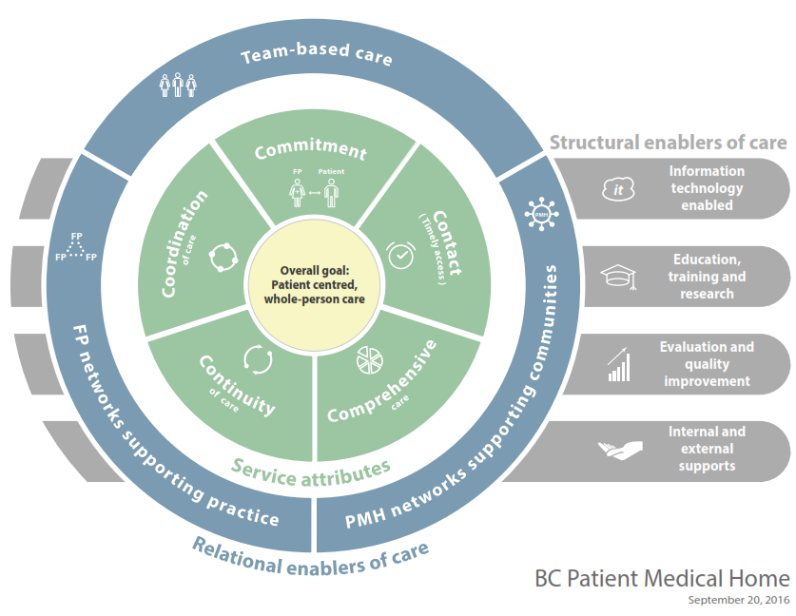

Introduction
The information provided in this document is the result of a number of workshops, discussions and forums held with rural GPs and divisions serving rural communities since June 2016. This is part of the work supported by the Network of Divisions serving rural communities.

Questions for feedback
- What strengths and assets do we already have that we can sustain and build on (and not break)?
- Where are there opportunities to change/improve?
- What barriers do we need to overcome?
- What enablers do we need to move forward?

Overall goal

Care is easily navigated and centered on the needs of the patient, family, and community. Patients are empowered in optimal self-management, and contribute to the development and assessment of the practice and community care models. Care will be delivered in a culturally appropriate manner with attention to social determinants of health and marginalized populations.

RURAL ENHANCEMENT:
- Rural GPs often provide patient-centered, whole-person care, wrapping services around the patient. They are grounded in their communities and have an understanding of their patients’ and community determinants of health including socio-economic, geographic and cultural factors.
- Many rural GPs already work with a community of providers to bring together the full spectrum of acute and community care - including primary and specialized care, as well as acute and residential care.

Service attributes

A Patient’s Medical Home (PMH) will ensure that patients have access to a personal family physician (or in some cases a NP) who will be the responsible provider (MRP) of his or her medical care. Physicians have a deﬁned patient panel and patients and physicians have a shared understanding of their mutual therapeutic relationship.

RURAL ENHANCEMENT:
- In small communities providing the full spectrum of acute and community care, with limited numbers of physicians, a team approach to care is needed. Patients may have a relationship with a rural GP, nurse practitioner or team of primary care providers in a community, who may oversee a shared patient panel or alternate as the patient’s most responsible provider (MRP) at different times in the patient’s journey..

Patients are able to access their own family physician, or failing that, their Medical Home/ family practice, on the same day if needed. Patients know how to appropriately access advice and care on a 24/7 basis.

RURAL ENHANCEMENT:
- In small communities, people generally know how to access care and do so appropriately.
- After-hours access, for both acute and primary care, varies from community to community and may include the Emergency Dep't.
- Patients may access a primary care provider on the same day if needed, in family practices, local facilities and/or through team-based and enhanced virtual connections such as e-mail, telephone or video conferencing. Geographic barriers to timely access are addressed where possible, and there is an opportunity to advocate for and to use virtual care options more effectively to enhance access.

The PMH provides delivery of, and linkages to comprehensive services. The speciﬁc comprehensive services provided through the network of PMH and network of PMHs are determined by context, considering both community need and also available resources. A set of core services will be included regardless of context:
- Care of patients across the life cycle (newborn to end of life and palliative care),
- Care across clinical settings (e.g. ambulatory / oﬃce practice, hospital and LTC institutions, emergency care settings, care in the home) and geographic service areas (remote, rural, urban, metro),
- The full spectrum of services provided within the regulated scope of family practice.

A wide spectrum of primary care clinical services (health promotion and prevention, diagnosis and management of undifferentiated presenting problems, acute and chronic disease management, mental health care, maternity care) and appropriate procedural medicine.

RURAL ENHANCEMENT:
- Rural GPs, NPs, and other primary care providers actively collaborate to coordinate a full spectrum of comprehensive services, and need to be geographically networked with regional and provincial specialized services that support local care.
- The rural generalist model of care is naturally comprehensive, with GPs providing a wide scope of care including emergency, maternity, home and palliative care. Where rural GPs practice in a variety of community settings, they may have less time to spend seeing patients in the office setting.

Longitudinal relationships support patient care across the continuum of patient care, spanning all settings. The enduring relationship between the patient, family physician (or NP where appropriate) and PMH team is key, and needs to be supported by informational continuity (two way communications that informs appropriate and timely care).

RURAL ENHANCEMENT:
- Rural GPs can provide excellent continuity of care through cohesive, small teams of primary care providers. Teams can collaborate and integrate with the broader community of care across geographic locations – to enhance appropriate and timely care and smooth patient transitions.

The PMH is the hub for the coordination of care through informational continuity and personal relationships and networks with other PMHs, inter-professional team members within and linked to the practice and linkages to specialty and specialized services across the care domains. Where services are provided outside the PMH, simple and clear pathways will be established to support patients as they transition to and from specialized services. Patients are empowered to participate in the coordination of their care through access to their own medical information and shared decision making with their physician/PMH team.

RURAL ENHANCEMENT:
- In rural communities, communication processes are often simpler and more flexible between rural GPs who often work in the same building or have a close relationships with colleagues, allied health providers, and other services..
- The 'coordination of care' challenge in rural communities lies primarily in coordination outside of the community, for example with patient transport and with PHSA cancer care services.
  - Patient care outside of the community needs to be coordinated by the team.
  - Patients must be significantly supported to navigate the complexities of geography, weather conditions and service boundaries.
  - Links to networks as well as enhancements in virtual care and patient transport can create clearer pathways to care, and support patient transitions.

Relational enablers of care

The PMH generally includes more than one FP working with an expanded inter-professional team within the practice, and / or linked to the practice, with a focus on person focused relationship based care. Providers within the practice are working to optimized scope.

RURAL ENHANCEMENT:
- Many rural GPs are already actively collaborating with expanded inter-professional teams that may include other physicians, NPs, RNs, specialists and other care providers within a practice, facility, community and/or across a geographic region.
- Teams will look different from community to community. They are best created from the ground up to allow strong, collegial relationships to evolve.
- Effective team members have mutual respect for each other’s expertise, with flexibility to develop and adapt roles as appropriate to meet a variety of local circumstances and practical needs. Service flow and approaches to care delivery vary from community to community.
- Teams enhance and stabilize the health care workforce in rural communities to reduce the fragility of the rural health care system. Teams increase both security of care provision for patients and sustainability of workload for providers.

FPs are part of a clinical network working together to meet the comprehensive care needs of their patients and the patients of other PMHs in the community including extended hours of service, cross coverage, and/or on-call.

RURAL ENHANCEMENT:
- Rural GPs and primary care teams are part of a clinical network that collaborates to meet the comprehensive care needs of their patients and community, and at times, within a region and remote areas to provide extended hours of service, cross coverage and/or on-call support, shared locums, and the full spectrum of acute and community care.

The PMHs are networked through the Division of Family Practice (or other similar community care service organization where Divisions may not exist) to enable better coordination, partnership and integration with health authority and non-governmental community services (Primary Care Home) and the broader system of health care.

RURAL ENHANCEMENT:
- Rural communities work together to provide the full spectrum of care, with networks of collegial relationships between rural GPs and community teams, groups and agencies bringing together shared supports to help address unique rural challenges and gaps.

System enablers of care

Physicians, providers and staff in the practice are IT enabled, including optimized EMR use and data collection methods to inform quality improvements in patient care and practice workflow. The EMR is able to link appropriately with other providers and parts of the system, including other community providers, pharmacies and acute care facilities. Virtual care options including access to appropriate email, telephone or video conferencing advice/consults are used and optimized.

RURAL ENHANCEMENT:
- Electronic Medical Record systems must be enhanced to accommodate various models of rural team-based care. Patient information is shared among the team with the explicit consent of patients as relationships can be close in small communities. Enhancements to virtual care and patient’s comfort with technology are used to improve patient access and transitions.

The PMH promotes mentoring, peer coaching for continuing professional development, training and research. This will include providing support to new grads and recruits coming to the community, providing training to medical students, residents and allied health providers within the practice, participating in peer led small group learning sessions, and research within the PMH or as part of a network.

RURAL ENHANCEMENT:
- Education, mentoring, peer coaching for continuing professional development, training and research must be rurally-relevant and provided in communities.

Physicians, other providers in the PMH, and patients are involved in clinical quality improvement activities at a professional, practice, community and system level.
RURAL ENHANCEMENT:
- The rural generalist physician voice must be represented at all stages of evaluation to ensure that outcomes represent the experience of physicians practicing in rural settings, and that they are interpreted and implemented appropriately.
- Rural providers participate in evaluation processes to help demonstrate the successes, challenges, improvement areas and progress of local changes and improvements that are relevant to rural care provision.

The PMH has a business model which supports longitudinal, comprehensive, coordinated, team-based care, and linkages with specialized services. Practices are supported to enable this model of primary care and integrated care through provincial and regional policies and systems.

RURAL ENHANCEMENT:
- Funding models, allocation of human resources to support generalists and other supports need to be flexible to meet a variety of local circumstances.
- There is a focus on collaboration between partners to improve broader external supports. For example, a focus on effective patient transport and internet service provision for patients in remote areas, which will further support the goals of the model of care.

